**Business Problem**

In recent years, City Hotel and Resort Hotel have seen high cancellation rates. Each hotel is now dealing with a number of issues as a result, including fewer revenues and less than ideal hotel room use. Consequently, lowering cancellation rates is both hotels' primary goal in order to increase their efficiency in generating revenue, and for us to offer thorough business advice to address this problem.

The analysis of hotel booking cancellations as well as other factors that have no bearing on their business and yearly revenue generation are the main topics of this report.

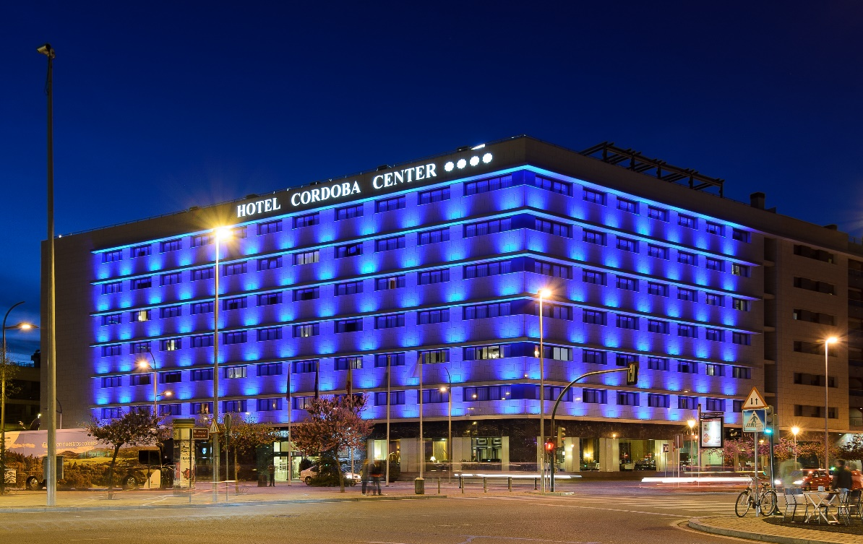

**Assumptions**

1. No unusual occurrences between 2015 and 2017 will have a substantial impact on the data used.

2. The information is still current and can be used to analyze a hotel's possible plans in an efficient manner.

3. There are no unanticipated negatives to the hotel employing any advised technique.

4. The hotels are not currently using any of the suggested solutions.

5. The biggest factor affecting the effectiveness of earning income is booking

6. Cancellations result in vacant rooms for the booked length of time.

7. Clients make hotel reservations the same year they make cancellations.

**Research Question**

1. What are the variables that affect hotel reservation cancellations?

2. How can we make hotel reservations cancellations better?

3. How will hotels be assisted in making pricing and promotional decisions?

**Hypothesis**

1. More cancellations occur when prices are higher.

2. When there is a longer waiting list, customers tend to cancel more frequently.

3. The majority of clients are coming from offline travel agents to make their reservations.

The accompanying bar graph shows the percentage of reservation that are cancelled and those are not it is obvious that there are still a significant number of reservations that have not been cancelled there are still 37% of clients who cancelled their reservation which have a significant impact on the hotel’s earnings

In comparison to resort hotel city hotels have more bookings it is possible that resort hotels are more expensive than those are in cities

The line graph above shows that on certain days the average daily rate for a city hotel is less than that of a resort hotel and on other days it is even less it goes without saying that weekends and holidays may see a rise in resort hotel rate

We have developed the grouped paragraph to analyze the months with the highest and the lowest reservation level according to reservation status as can be seen both the number of confirmed reservations and the number of canceled reservations are large in the month of August whereas January is the month with the most cancelation reservation

The biography demonstrate that cancelation are most common when prices are greater and are least common when they are lower therefore the cost of the accommodation is solely responsible for the cancelation

now lets see which country has the highest reservation canceled the top country is Portugal with the highest number of cancelations

Let’s check the area from where guests are visiting the hotel and making reservation is it coming from direct or group online or offline travel agents?

around 46% of the client come from online travel agents whereas 27% comes from groups only 4% of the client’s book hotels directly by visiting them and making reservations

As seen in the graph reservation are canceled when the average daily rate is higher than when it is not canceled it clearly proves all the above analysis that the highest price leads to higher cancelation

**Suggestions:-**

* Cancelation rate rise as the price turns in order to prevent cancelation of reservation hotel could work on their price strategy and try to lower the rate for specific hotel based on location they can also provide some discount to the customers.
* As the ratio of the cancelation and not cancelation of the resort hotel is higher in the resort hotel than in the city hotels so the hotel should provide a reasonable discount on the room price on weekends or on holidays.
* In the month of January hotel can start campaigning or marketing with the reasonable amount to increase the revenue as the cancelation is the highest in this month.
* They can also increase the quality of their hotel and their services mainly in the Portugal to reduce the cancelation rate.